# Digital Tools for Interior Design: Bridging Hand Skills and Technology

The digital revolution has transformed how interior designers work, yet it hasn't diminished the importance of hand-drawing. This module builds on our previous exploration of colour theory and sets you up for creating professional presentations in our next session.

Today's design industry demands both traditional craftsmanship and tech savvy. Digital tools won't replace the hand skills you're developing—they'll actually complement them, helping you refine, document and showcase your ideas with greater accuracy and professional flair.



Fig.1 (Luna Lovegood on [Pexels](https://www.pexels.com/photo/4087480/), 2025) The modern designer's hybrid workspace

## 1. Digital Basics: Creating Your Digital Workspace

### Organising Your Digital Life

As we talked about in Lesson 1, keeping an organized digital workspace is crucial for professional design work. Instead of going over those organizational principles again, let's focus on how this organization specifically supports your design workflow when combining hand drawings with digital tools.

Your well-structured folder system (covered previously) creates a backbone that makes finding your hand sketches, reference materials, and digital assets much easier when you're pulling them together for presentations.

### Workspace Setup & Workflow

Create a consistent digital workflow that supports the design process:

1. **Capture**: Snap clear photos of your hand sketches using your phone or scanner
2. **Import**: Upload these images to Canva as your starting point
3. **Enhance**: Layer in text, colour blocks, and additional images
4. **Organise**: Use Canva's alignment tools (in the top menu) to tidy up your elements
5. **Export**: Save your work through the "Download" button, picking the right format

**Pro tip**: Good lighting makes a huge difference when photographing sketches. Natural daylight works wonders—steer clear of harsh shadows that might hide details in your work.

## 2. Integration Techniques: Blending Hand and Digital Methods

### Hand-to-Digital Workflow

Your hand drawings carry a personal touch that purely digital work often misses. To keep this quality while gaining digital advantages:

1. Sketch initial concepts by hand
2. Photograph or scan these sketches (300dpi resolution—that's 300 dots per inch, the printing industry standard)
3. Pull them into Canva as your foundation layer
4. Spruce them up with digital elements while keeping their original character
5. Add professional labels, dimensions, and notes

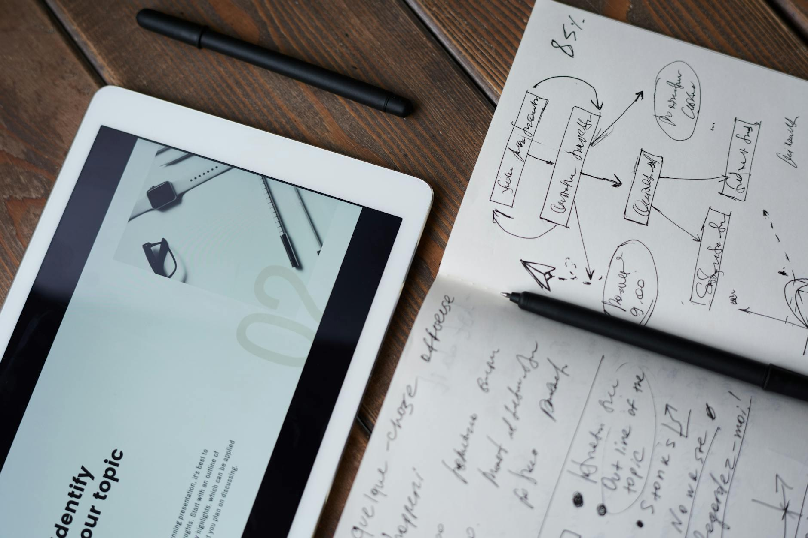

Fig.2 (fauxels on [Pexels](https://www.pexels.com/photo/3183170/), 2025) The hand-to-digital transformation process - preserving creative expression while adding professional polish

**Demonstration example**: A room perspective you've sketched by hand becomes much more impactful in Canva when you add digital colour blocks showing your chosen palette, plus text explaining your design choices.

### Documentation Methods

Clear documentation helps get your ideas across effectively:

* Label all drawings consistently (e.g., "Floor Plan - Smith Residence - Kitchen")
* Include scale info where needed (like "1:50" or "1cm = 0.5m")
* Create a simple key for any symbols or shorthand
* Make sure text is readable when printed or viewed on screen (at least 12pt font)

### Quality Standards

When preparing files for your portfolio or client presentations, stick to these professional standards:

* **Resolution**: Go with 300dpi for anything headed to print
* **File formats**: Save as PDF for final work, JPG for web use
* **Text legibility**: Double-check that all text reads easily at the intended size
* **Colour accuracy**: Verify that digital colours match your physical samples as closely as possible

### Sharing Your Work Effectively

Building on what we covered about file organization and sharing in Lesson 1, think about how these practices specifically support presenting your color and material choices:

* When sharing digital presentations with your hand-drawn work, remember to keep file sizes manageable as we discussed before
* For presentations where color accuracy matters, be aware that different screens show colors differently—what looks perfect on your laptop might appear off on a client's tablet
* Within your organized project folders (from Lesson 1), set up a dedicated space just for color and material documentation to streamline your workflow

**Over to you**: Consider how these digital tools might boost your design process. How could Canva help showcase your colour schemes more effectively? In what ways might digital documentation improve how you communicate ideas? Pick one specific presentation technique from today's lesson that you'd like to try in your next project, and jot it down in your design journal.